Neethu K J

Student ID: GS197

|  |  |
| --- | --- |
| ONLINE JOB PORTAL | Version 1.0 |
| Software requirement specification | 21/04/25 |

Online Job portal

Software Requirement Specifications

Table of Contents

**Description Page No**

1. **Introduction 2**

1.1 Purpose 2

* 1. Scope 2
  2. Objectives 3

1. **Functional Requirements 4**

2.1 Primary actors of the system 4

2.2 Use Case Diagram 5

2.3 User Stories 7

2.4 Business Process Diagram 9

1. **Non-Functional Requirements 9**
2. **Technical Requirements 10**
3. **Conclusion 10**

Job Portal

Software Requirements Specification (SRS)

Project for .Net Core/Angular Training Boot Camp

1. **Introduction**

Job Portal systems are commonly designed with the significant topographies of higher engagement for both employers and job seekers and can avail the benefits of these features to enhance their user experiences to select the right candidate on right place. This online job portal will show the available jobs , posted by the job providers and it will allow the job seekers to find and apply for the relevant jobs based on their qualifications.

1.1 Purpose

The purpose of designing the online job portal is to give the job seekers a platform for finding a right and a satisfactory job according to their qualification.

In short, the purpose of this SRS document is to provide a detailed overview of our software product, its parameters and goals. This document describes the project’s target audience and its user interface, hardware and software requirements. It defines how our client, team and audience see the product and its functionality. It clearly states both the functional and nonfunctional requirements. Nonetheless, it helps any designer and developer to assist in software delivery lifecycle (SDLC) processes.

1.2 Scope

This software system will be an online management system for a job seeker and an organization looking for job applicants. This system will be designed to maximize the job opportunities thereby help the job seekers to meet their needs while remaining easy to understand and use. More specifically, this system is designed to allow a company to manage and communicate with a group of job applicants and will moreover allow a job seeker to communicate with a group of companies. The system also contains a relational database containing a list of CV and job advertisement.

The main functionalities or features of the system includes search, save and apply for the job, posting the job vacancy, Application tracking.

The main user roles that the system will cater to are

* Job seekers
* Job providers
* Portal Admin

1.3 Objectives

The high-level objectives of the system include

* **Attract Top Talent:** By being a professional and user-friendly portal helps to reflects your company’s values and culture, attracting candidates who align with your organization.
* **Enhances Candidate Experience:** Streamlined application processes increase the likelihood of qualified candidates completing their applications.
* **Improves Employer Branding:** This job portal is often the first impression candidates have of your company. A well-designed portal reinforces a strong employer brand.
* **Saves Time and Resources:** Automated features like application tracking, pre-screening, and communication templates streamline recruitment workflows.

Goals of a Job Portal System:

* **Streamline the Recruitment Process:**
  + Make it faster and easier for employers to post jobs and manage applications.
  + Enable job seekers to apply to multiple jobs quickly.
* **Improve Job Matching:**
  + Use filters, algorithms, or AI to match candidates to suitable jobs based on skills, experience, and preferences.
* **Enhance Accessibility:**
  + Provide a centralized platform where anyone can access job listings, regardless of location or device.
* **Provide Transparency:**
  + Allow users to see job descriptions, company details, application status, and sometimes even salary ranges.
* **Facilitate Communication**:
  + Enable direct messaging or notifications between recruiters and candidates.

1. **Functional Requirements**
   1. Primary actors of the system

Primary actors of the system are

* Job seeker: Individuals seeking employment opportunities. They can create and manage personal profiles, search, save and apply for jobs ,Track application status, Communicate with both job providers and admin
* Job provider :A company or individual looking to hire employees. They can create and manage profile , post jobs , Track applications , search and filter candidate profiles , communicate with both job seekers and admin.
* Job portal admin: Manage and monitors job portal system . They can Manage user profiles, generate reports and analytics, issue sorting , manage payments and subscription
  1. Use case Diagram

**Job portal**

Job seeker

Login

Registration

Job search

Job save

Apply on job

Resume creation

Issue reporting

Instant messaging

Job portal

Job provider

Login

Registration

Job posting

Application tracking

Resume filtration

Interview scheduling

Issue reporting

Instant messaging

Job portal

Portal Admin

User activity

analyzation

Authentication

Skill enhancement

Banner updation

Issue sorting

* 1. User stories

|  |  |  |
| --- | --- | --- |
| AS A [Type of user] | I NEED TO [do some task] | SO THAT I CAN[get some result] |
| Job seeker | Register in to the application by entering details | Login into the job portal system and use the system capabilities reserved for registered users |
| Job seeker | Create my profile by entering details | Make my data available to job providers |
| Job seeker | Search desired jobs using keywords and filter options | View different job vacancies based on my qualifications |
| Job seeker | Apply for a job from the job portal | Be considered for the position and potentially secure employment. |
| Job seeker | Build my resume to highlight my skills and experience | Notify the employer about my experience and skill, there by making them consider me for the job position |
| Job seeker | Save jobs which is already navigated through and can bookmark them | Refer back them when they need to review again, edit or re-submit the applications. |
| Job seeker | Contact employer via email or chat | Communicate with the job provider regarding job vacancies |
| Job seeker | Select interview timings from the available options | Attend the job interview in my convenient time. |
| Job seeker | Get an option to become a premium user by payment | Use the system capabilities reserved for premium users and to increase my cv visibility |
| Job seeker | Contact admin via email or instant message if any issue arises | Get help from admin to sort out issue with my login account |

|  |  |  |
| --- | --- | --- |
| AS A [Type of user] | I NEED TO [do some task] | SO THAT I CAN[get some result] |
| Job Provider | Register in to the application by entering details | Login into the job portal system and use the system capabilities reserved for registered users |
| Job Provider | Create company profile by entering details | List out in job portal system and use registered employer features and find desired candidates for my company job vacancy |
| Job Provider | Post a job on the job portal | Advertise job openings so that attract potential candidates |
| Job Provider | Track job applications by reviewing, accepting or rejecting applications from applied candidates | Assess their qualifications and to determine whether to move forward with hiring process |
| Job Provider | Filter resume by entering certain keywords | Get qualified candidates based on their job profile given |
| Job Provider | Conduct interviews using video calling apps | Make hiring process much better and easy |
| Job Provider | Contact admin via email or instant message if any issue arises | Get help from admin to sort out issue with my login account |

|  |  |  |
| --- | --- | --- |
| AS A [Type of user] | I NEED TO [do some task] | SO THAT I CAN[get some result] |
| Job portal Admin | View and analyze user activity by receiving notifications of new job seekers, job providers and job postings | Analyze the user activity in the job portal system |
| Job portal Admin | Get weekly site performance report based on the user activity in the job portal system | Get an overview about my site performance and thereby I can make improvements if needed |
| Job portal Admin | Provide job seekers facility to enhance their skills by providing different courses(video) | Attract more job seekers to my job portal system and thereby help them to be skillful . |
| Job portal Admin | Authenticate job providers based on the company registration id and accept or reject the application based on it. | Avoid fake and spam job vacancy offers |
| Job portal Admin | Update banners by uploading image or posters | Improve my site look |
| Job portal Admin | Get notifications or message from the users if any issue arise and sort out the issue. | Help the users to use the job portal system conveniently |

* 1. Business Process Diagram

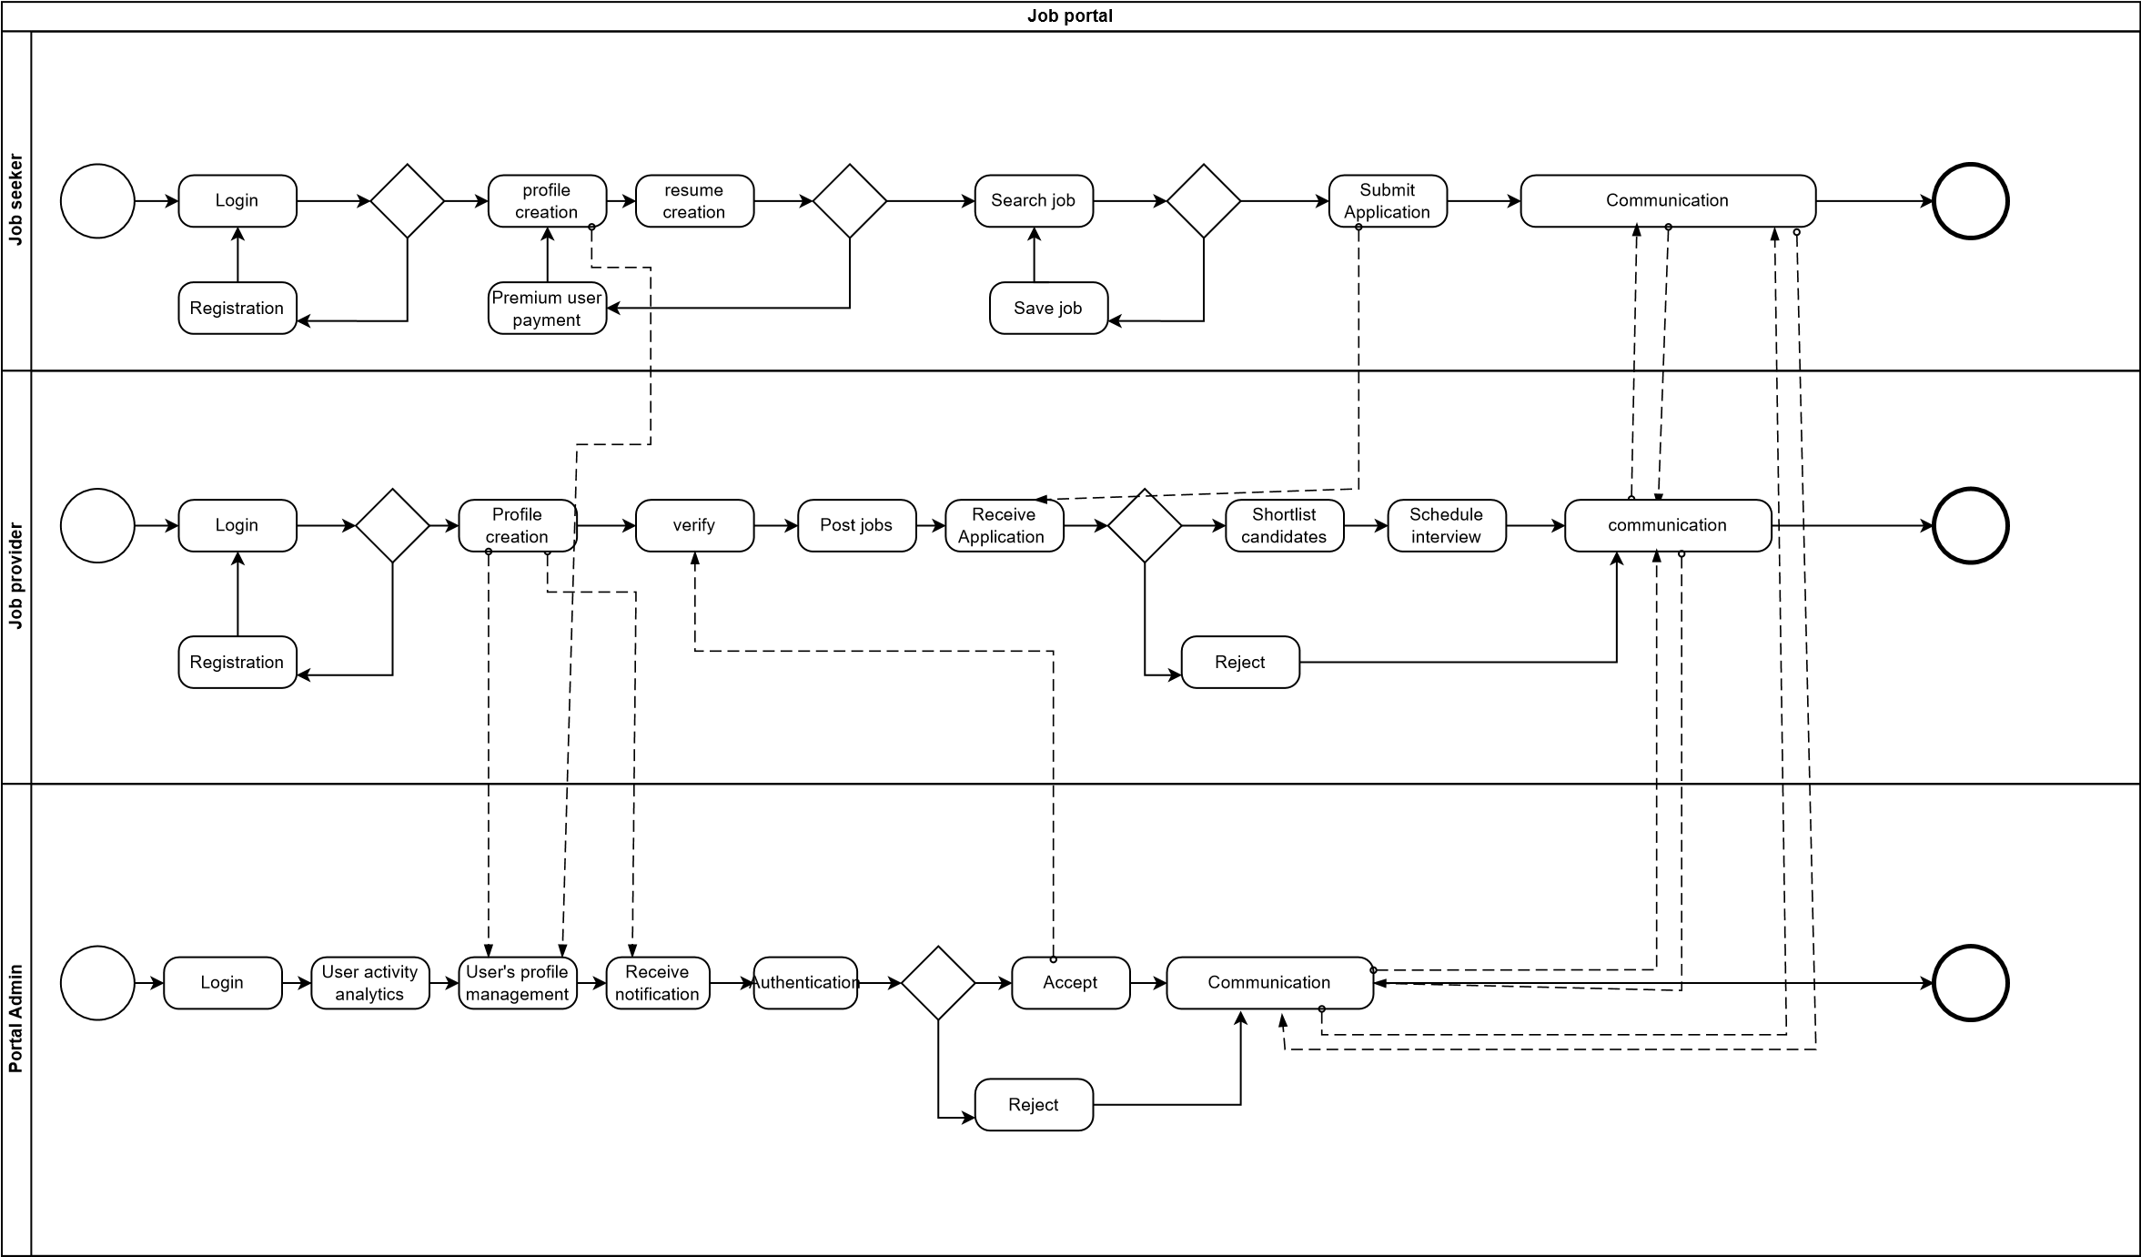

1. **Non-Functional Requirement**

* Performance:
  + Fast search and filter response times
  + Handle high traffic (scalable architecture)
* Scalability
  + Microservices or modular monolith
  + Load balancing for high concurrency
* Security
  + HTTPS and data encryption
  + SQL injection and XSS protection
  + Role-based access control (RBAC)
* Usability
  + Mobile-responsive UI
  + Clean and intuitive design
* Maintainability
  + Modular codebase
  + API versioning and documentation
* Availability & Reliability
  + High uptime (99.9%)
  + Database backup and recovery
  + Failover mechanisms

1. **Technical Requirements**

* Front-end Development
  + HTML/CSS/JavaScript
  + Angular
  + Bootstrap
* Back-end Development
  + ASP.Net Core, C#
  + Database – MS SQL Server
* Hardware specifications:
  + OS - Windows 10/11
  + RAM -16GB or more

1. **Conclusion**

The Job Portal System is designed to bridge the gap between job seekers and employers by offering a centralized, efficient, and user-friendly platform for job postings and applications. This SRS document outlines all essential requirements, ensuring that the development team, stakeholders, and end users have a clear and shared understanding of the system’s goals and functionalities.